Q 1: What is the emissions per capita of Canada?

17.72

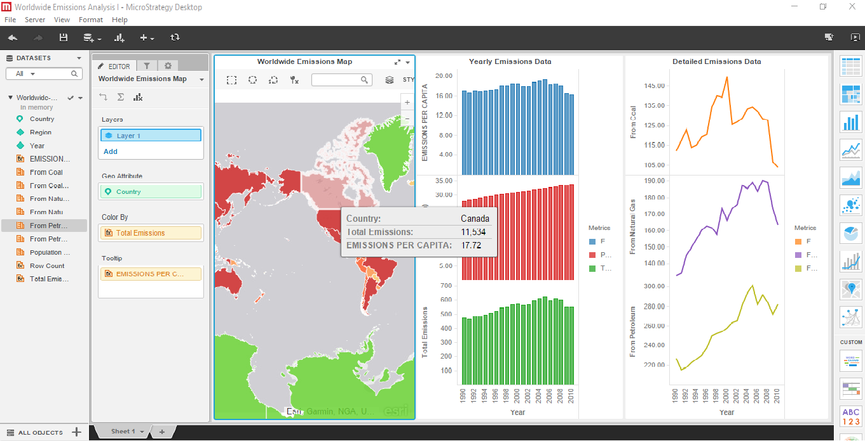

Q 2**:** What is the overall trend in worldwide emissions**?**

Emissions increases each year except in 2009 where it decreased for once. Line chart going upward only except year 2009.

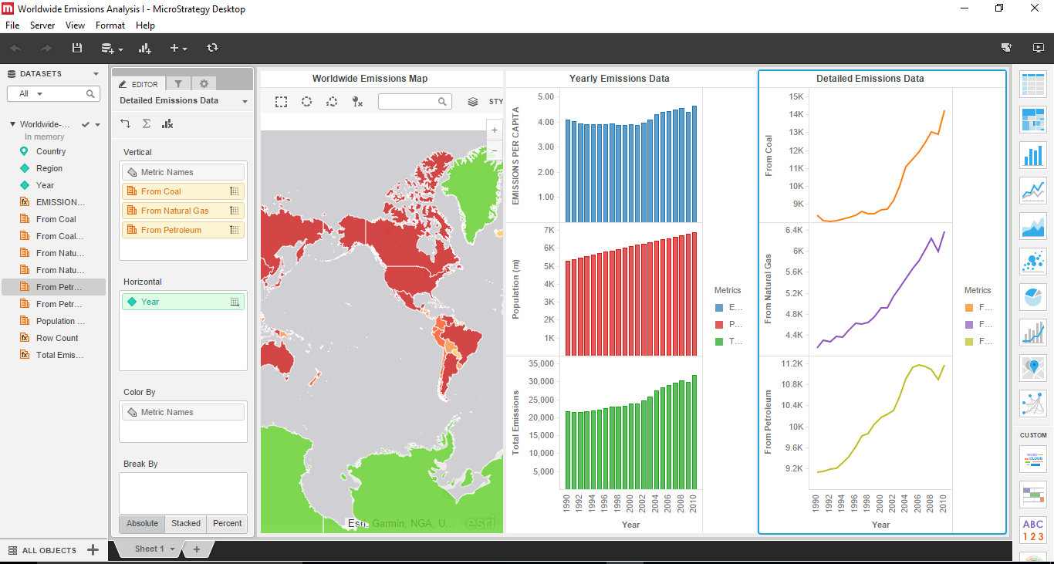

Q 3: Notice that overall emissions declined in 2009, the only year in the total number of years surveyed that indicates emissions decreases in all three emissions sources. Why is that? What broader socio-political context might explain this single yearly decrease?

Emissions decreases in 2009 due to global recession.

Showing the Canada Emission Fall in 2009 only.

